ITA0601 – MACHINE LEARNING
LAB EXPERIMENTS
EXP-16: Different Types Classification Algorithms and Evaluate Their Performance.
Dataset 1 – Student Performance Classification
Study Hours | Attendance (%) | Previous Marks | Assignments | Result
2 | 60 | 45 | 3 | Fail
3 | 65 | 50 | 4 | Fail
4 | 70 | 55 | 5 | Pass
5 | 75 | 60 | 6 | Pass
6 | 80 | 65 | 7 | Pass
7 | 85 | 70 | 8 | Pass
1 | 55 | 40 | 2 | Fail
2 | 62 | 48 | 3 | Fail
6 | 78 | 68 | 7 | Pass
8 | 90 | 75 | 9 | Pass
3 | 68 | 52 | 4 | Fail
7 | 88 | 72 | 8 | Pass
Python Code:
import pandas as pd
from sklearn.model_selection import train_test_split
from sklearn.preprocessing import LabelEncoder
from sklearn.linear_model import LogisticRegression
from sklearn.neighbors import KNeighborsClassifier
from sklearn.tree import DecisionTreeClassifier
from sklearn.naive_bayes import GaussianNB
from sklearn.svm import SVC
from sklearn.metrics import accuracy_score
data = {
"Study_Hours": [2,3,4,5,6,7,1,2,6,8,3,7],
"Attendance": [60,65,70,75,80,85,55,62,78,90,68,88],
"Previous_Marks": [45,50,55,60,65,70,40,48,68,75,52,72],
"Assignments": [3,4,5,6,7,8,2,3,7,9,4,8],
"Result": [
"Fail","Fail","Pass","Pass","Pass","Pass",
"Fail","Fail","Pass","Pass","Fail","Pass"
]
}
df = pd.DataFrame(data)
X = df[["Study_Hours", "Attendance",
"Previous_Marks", "Assignments"]]
y = LabelEncoder().fit_transform(df["Result"])
X_train, X_test, y_train, y_test = train_test_split(
X, y, test_size=0.3, random_state=42
)
models = {
"Logistic Regression": LogisticRegression(max_iter=1000),
"KNN": KNeighborsClassifier(n_neighbors=3),
"Decision Tree": DecisionTreeClassifier(random_state=42),
"Naive Bayes": GaussianNB(),
"SVM": SVC()
}
print("Dataset 1 - Classification Performance")
for name, model in models.items():
model.fit(X_train, y_train)
prediction = model.predict(X_test)
accuracy = accuracy_score(y_test, prediction)
print(name, "Accuracy:", round(accuracy * 100, 2), "%")
Output:
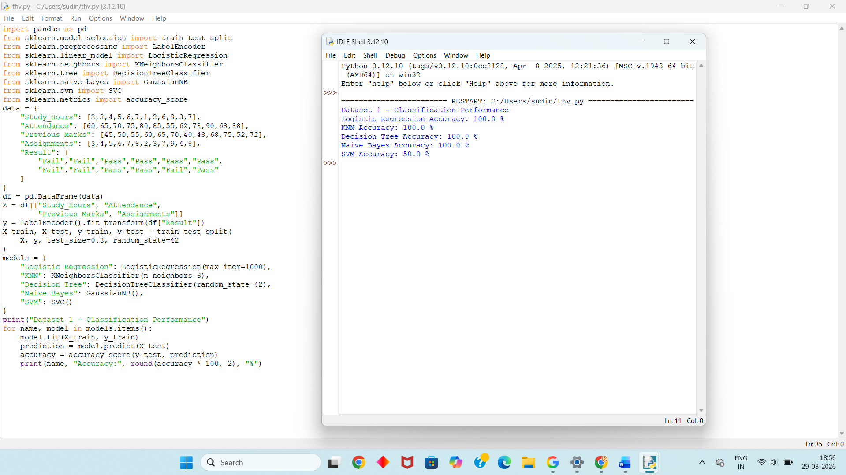
Dataset 2 – Customer Purchase Classification
Age | Income (₹000) | Shopping Score | Visits/Month | Purchase
22 | 25 | 30 | 2 | No
25 | 30 | 35 | 3 | No
28 | 40 | 45 | 4 | Yes
30 | 45 | 50 | 5 | Yes
35 | 55 | 60 | 6 | Yes
40 | 65 | 70 | 7 | Yes
21 | 22 | 25 | 1 | No
24 | 28 | 32 | 2 | No
32 | 48 | 55 | 5 | Yes
38 | 60 | 65 | 6 | Yes
27 | 35 | 40 | 3 | No
42 | 70 | 75 | 8 | Yes
Python Code:
import pandas as pd
from sklearn.model_selection import train_test_split
from sklearn.preprocessing import LabelEncoder
from sklearn.linear_model import LogisticRegression
from sklearn.neighbors import KNeighborsClassifier
from sklearn.tree import DecisionTreeClassifier
from sklearn.naive_bayes import GaussianNB
from sklearn.svm import SVC
from sklearn.metrics import accuracy_score
data = {
"Age": [22,25,28,30,35,40,21,24,32,38,27,42],
"Income": [25,30,40,45,55,65,22,28,48,60,35,70],
"Shopping_Score": [30,35,45,50,60,70,25,32,55,65,40,75],
"Visits": [2,3,4,5,6,7,1,2,5,6,3,8],
"Purchase": [
"No","No","Yes","Yes","Yes","Yes",
"No","No","Yes","Yes","No","Yes"
]
}
df = pd.DataFrame(data)
X = df[["Age", "Income", "Shopping_Score", "Visits"]]
y = LabelEncoder().fit_transform(df["Purchase"])
X_train, X_test, y_train, y_test = train_test_split(
X, y, test_size=0.3, random_state=42
)
models = {
"Logistic Regression": LogisticRegression(max_iter=1000),
"KNN": KNeighborsClassifier(n_neighbors=3),
"Decision Tree": DecisionTreeClassifier(random_state=42),
"Naive Bayes": GaussianNB(),
"SVM": SVC()
}
print("Dataset 2 - Classification Performance")
for name, model in models.items():
model.fit(X_train, y_train)
prediction = model.predict(X_test)
accuracy = accuracy_score(y_test, prediction)
print(name, "Accuracy:", round(accuracy * 100, 2), "%")
Output:
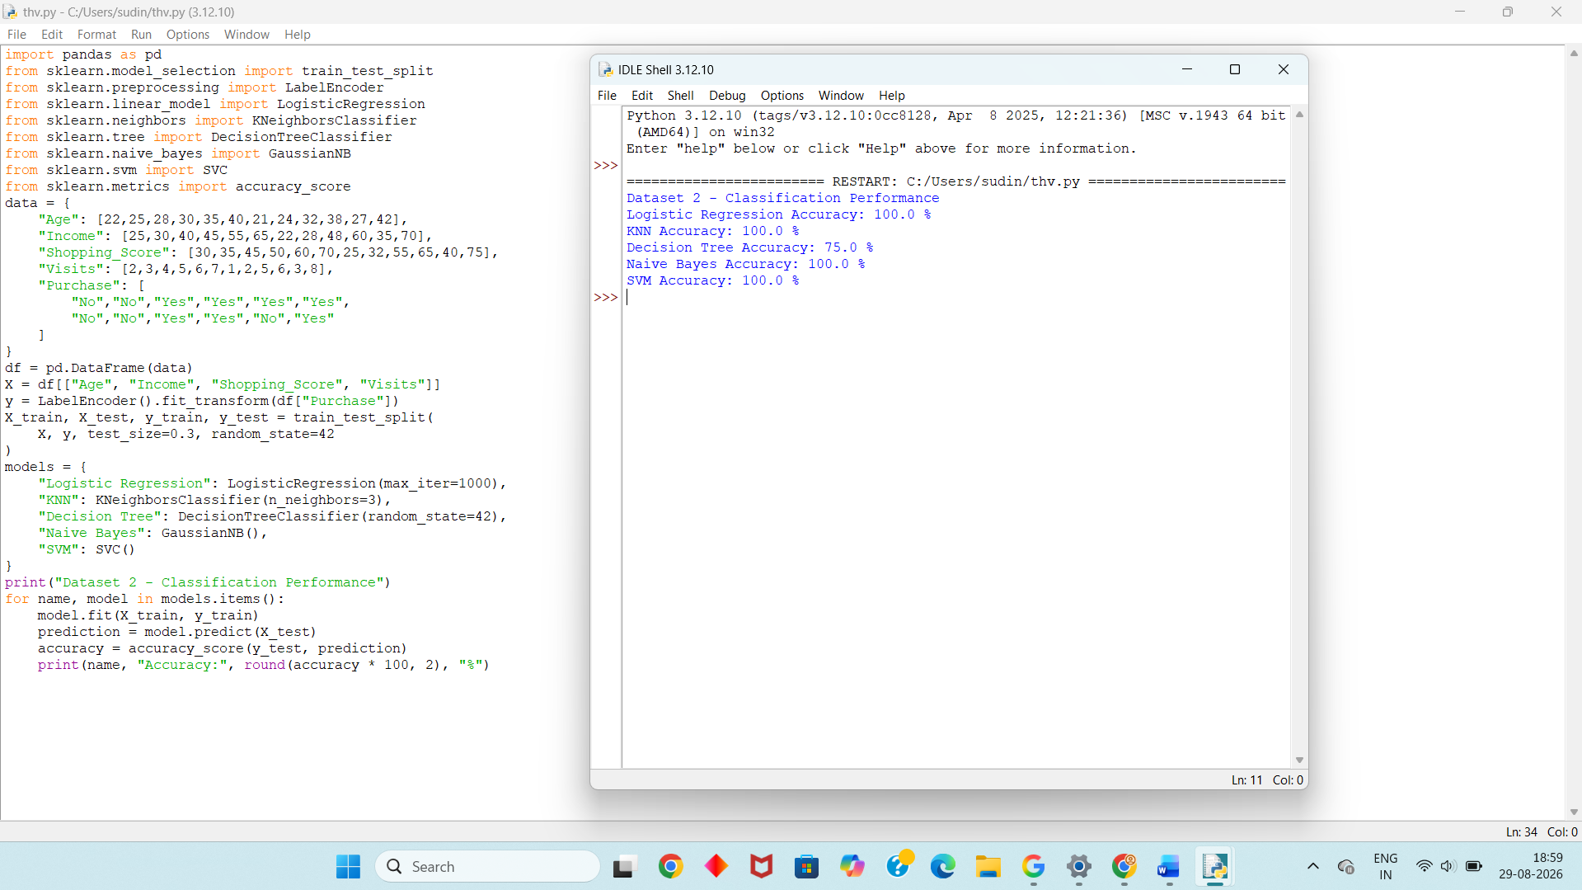
Dataset 3 – Employee Promotion Classification
Experience | Performance Score | Training Hours | Projects | Promotion
1 | 50 | 10 | 1 | No
2 | 55 | 12 | 2 | No
3 | 60 | 15 | 2 | No
4 | 65 | 18 | 3 | Yes
5 | 70 | 20 | 4 | Yes
6 | 75 | 22 | 5 | Yes
2 | 52 | 10 | 1 | No
3 | 58 | 14 | 2 | No
5 | 72 | 21 | 4 | Yes
7 | 80 | 25 | 6 | Yes
4 | 63 | 17 | 3 | Yes
6 | 78 | 24 | 5 | Yes
Python Code:
import pandas as pd
from sklearn.model_selection import train_test_split
from sklearn.preprocessing import LabelEncoder
from sklearn.linear_model import LogisticRegression
from sklearn.neighbors import KNeighborsClassifier
from sklearn.tree import DecisionTreeClassifier
from sklearn.naive_bayes import GaussianNB
from sklearn.svm import SVC
from sklearn.metrics import accuracy_score
data = {
"Experience": [1,2,3,4,5,6,2,3,5,7,4,6],
"Performance": [50,55,60,65,70,75,52,58,72,80,63,78],
"Training_Hours": [10,12,15,18,20,22,10,14,21,25,17,24],
"Projects": [1,2,2,3,4,5,1,2,4,6,3,5],
"Promotion": [
"No","No","No","Yes","Yes","Yes",
"No","No","Yes","Yes","Yes","Yes"
]
}
df = pd.DataFrame(data)
X = df[["Experience", "Performance",
"Training_Hours", "Projects"]]
y = LabelEncoder().fit_transform(df["Promotion"])
X_train, X_test, y_train, y_test = train_test_split(
X, y, test_size=0.3, random_state=42
)
models = {
"Logistic Regression": LogisticRegression(max_iter=1000),
"KNN": KNeighborsClassifier(n_neighbors=3),
"Decision Tree": DecisionTreeClassifier(random_state=42),
"Naive Bayes": GaussianNB(),
"SVM": SVC()
}
print("Dataset 3 - Classification Performance")
for name, model in models.items():
model.fit(X_train, y_train)
prediction = model.predict(X_test)
accuracy = accuracy_score(y_test, prediction)
print(name, "Accuracy:", round(accuracy * 100, 2), "%")

Output:
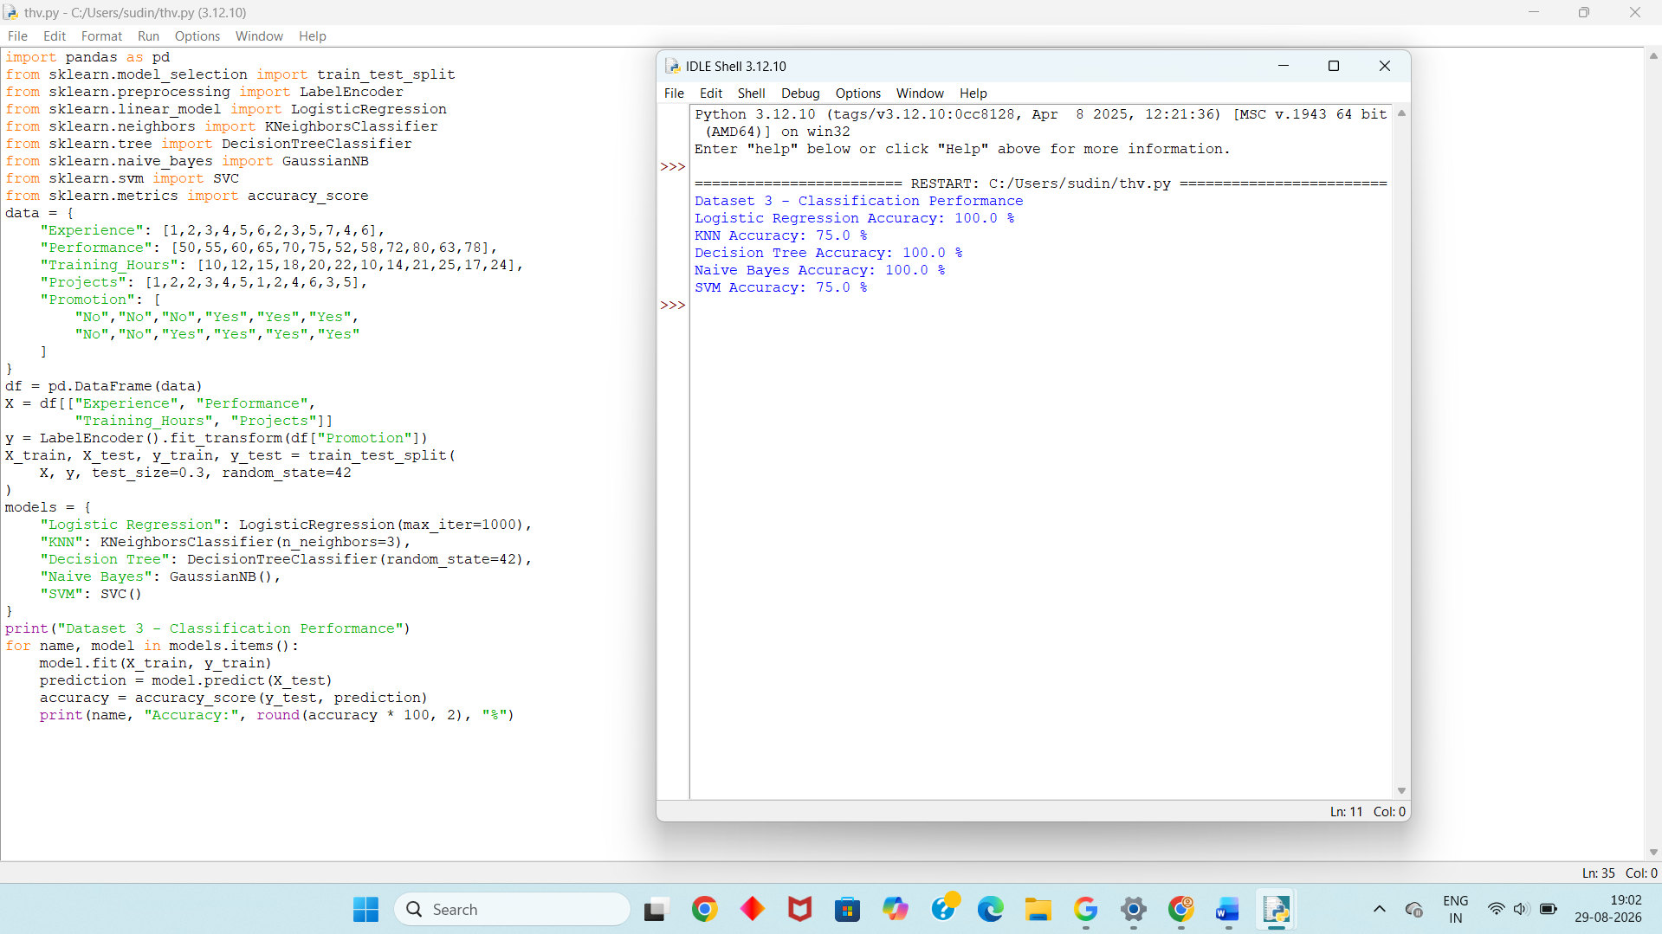
Dataset 4 – Loan Approval Classification
Age | Income (₹000) | Credit Score | Loan Amount (₹000) | Approval
25 | 25 | 580 | 300 | No
28 | 30 | 600 | 350 | No
30 | 40 | 650 | 400 | Yes
35 | 50 | 700 | 450 | Yes
40 | 60 | 720 | 500 | Yes
45 | 70 | 750 | 550 | Yes
24 | 22 | 560 | 300 | No
27 | 28 | 590 | 350 | No
33 | 45 | 680 | 400 | Yes
38 | 55 | 710 | 450 | Yes
29 | 35 | 620 | 400 | No
42 | 65 | 740 | 500 | Yes
Python Code:
import pandas as pd
from sklearn.model_selection import train_test_split
from sklearn.preprocessing import LabelEncoder
from sklearn.linear_model import LogisticRegression
from sklearn.neighbors import KNeighborsClassifier
from sklearn.tree import DecisionTreeClassifier
from sklearn.naive_bayes import GaussianNB
from sklearn.svm import SVC
from sklearn.metrics import accuracy_score
data = {
"Age": [25,28,30,35,40,45,24,27,33,38,29,42],
"Income": [25,30,40,50,60,70,22,28,45,55,35,65],
"Credit_Score": [580,600,650,700,720,750,560,590,680,710,620,740],
"Loan_Amount": [300,350,400,450,500,550,300,350,400,450,400,500],
"Approval": [
"No","No","Yes","Yes","Yes","Yes",
"No","No","Yes","Yes","No","Yes"
]
}
df = pd.DataFrame(data)
X = df[["Age", "Income", "Credit_Score", "Loan_Amount"]]
y = LabelEncoder().fit_transform(df["Approval"])
X_train, X_test, y_train, y_test = train_test_split(
X, y, test_size=0.3, random_state=42
)
models = {
"Logistic Regression": LogisticRegression(max_iter=1000),
"KNN": KNeighborsClassifier(n_neighbors=3),
"Decision Tree": DecisionTreeClassifier(random_state=42),
"Naive Bayes": GaussianNB(),
"SVM": SVC()
}
print("Dataset 4 - Classification Performance")
for name, model in models.items():
model.fit(X_train, y_train)
prediction = model.predict(X_test)
accuracy = accuracy_score(y_test, prediction)
print(name, "Accuracy:", round(accuracy * 100, 2), "%")
Output:
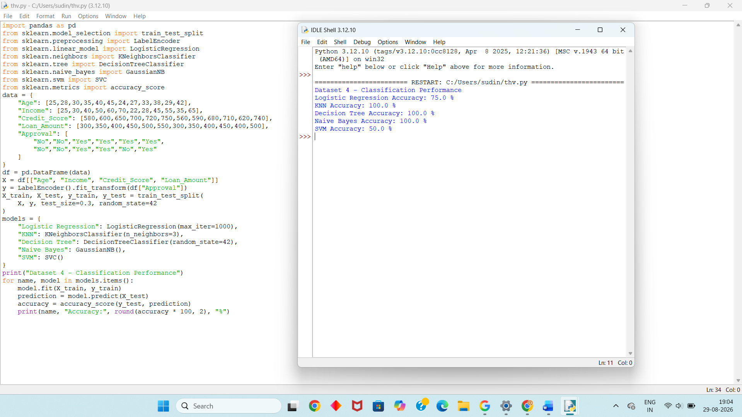
Dataset 5 – Heart Disease Classification
Age | Blood Pressure | Cholesterol | Heart Rate | Disease
25 | 110 | 180 | 80 | No
30 | 115 | 190 | 82 | No
35 | 125 | 210 | 85 | No
40 | 135 | 230 | 90 | Yes
45 | 140 | 240 | 92 | Yes
50 | 150 | 250 | 95 | Yes
28 | 112 | 185 | 78 | No
32 | 120 | 200 | 80 | No
42 | 138 | 235 | 91 | Yes
48 | 145 | 245 | 94 | Yes
38 | 130 | 220 | 88 | Yes
55 | 155 | 260 | 98 | Yes
Python Code:
import pandas as pd
from sklearn.model_selection import train_test_split
from sklearn.preprocessing import LabelEncoder
from sklearn.linear_model import LogisticRegression
from sklearn.neighbors import KNeighborsClassifier
from sklearn.tree import DecisionTreeClassifier
from sklearn.naive_bayes import GaussianNB
from sklearn.svm import SVC
from sklearn.metrics import accuracy_score
data = {
"Age": [25,30,35,40,45,50,28,32,42,48,38,55],
"Blood_Pressure": [110,115,125,135,140,150,112,120,138,145,130,155],
"Cholesterol": [180,190,210,230,240,250,185,200,235,245,220,260],
"Heart_Rate": [80,82,85,90,92,95,78,80,91,94,88,98],
"Disease": [
"No","No","No","Yes","Yes","Yes",
"No","No","Yes","Yes","Yes","Yes"
]
}
df = pd.DataFrame(data)
X = df[["Age", "Blood_Pressure",
"Cholesterol", "Heart_Rate"]]
y = LabelEncoder().fit_transform(df["Disease"])
X_train, X_test, y_train, y_test = train_test_split(
X, y, test_size=0.3, random_state=42
)
models = {
"Logistic Regression": LogisticRegression(max_iter=1000),
"KNN": KNeighborsClassifier(n_neighbors=3),
"Decision Tree": DecisionTreeClassifier(random_state=42),
"Naive Bayes": GaussianNB(),
"SVM": SVC()
}
print("Dataset 5 - Classification Performance")
for name, model in models.items():
model.fit(X_train, y_train)
prediction = model.predict(X_test)
accuracy = accuracy_score(y_test, prediction)
print(name, "Accuracy:", round(accuracy * 100, 2), "%")
Output:
